Adaptive Steering Control Function – CGEA1.3

Functional Description

This STSS is a similar function to the Lincoln Adaptive Drive (as per CCD Control Function w Adaptive Drive - CGEA1.3 STSS). AWD Lincoln vehicles offer a CCD (Continuously Controlled Damping) setting via the Vehicle Dynamics Module (VDM). Non-AWD Lincoln vehicles do not have CCD and instead have a SASM (Steering Angle Sensor Module) in place of the VDM. However, the SASM supports the same CAN signals that the VDM supports for Lincoln Adaptive Drive.

Depending on the vehicle build combination, the HMI shall support one of the following menus:
- Adaptive Steering in Drive, Adaptive Steering in Sport (note: automatic transmission)
- Adaptive Steering (note: manual transmission)
- Drive Control
- Adaptive Drive Handling in “D”, Handling in “S”, Performance in “S”
This STSS handles “a” and “b” above. Please refer to CCD Control Function w Adaptive Drive - CGEA1.3 STSS for “c” and “d”. Please note that “a” and “b” have added a “System On/Off” choice starting with version 3.0 of this STSS. This is being done per marketing request to be able to easily demo to a customer the vehicle steering differences with the system on vs. off.

The Active Front Steering (AFS) system dynamically changes the ratio between the steering wheel and the road wheels. The AFS feature is tied to the SASM module. The SASM module supports the same CAN signals that the VDM supports for Lincoln Adaptive Drive, but they are now re-purposed for Ford Adaptive Steering.

A related STSS is the Active Front Steering RTT and Messages - CGEA 1.3 STSS. That STSS handles the warnings for the SASM module. This STSS (Adaptive Steering Control Function) enables the cluster menu settings. Thus, when this STSS is used, the Active Front Steering RTT and Messages - CGEA 1.3 STSS should also be used.

The AFS feature provides customers with different options to select the available steering modes via the settings menu. The Instrument Cluster uses the Personalization signals for the Message Center function to set these different options in the SASM.

The customer uses the message center switches and display to set the Adaptive Steering settings in the vehicle.

Interfaces

Interface Context Diagram (I/O Block Diagram)
Figure 1 Adaptive Steering Function Context Diagram
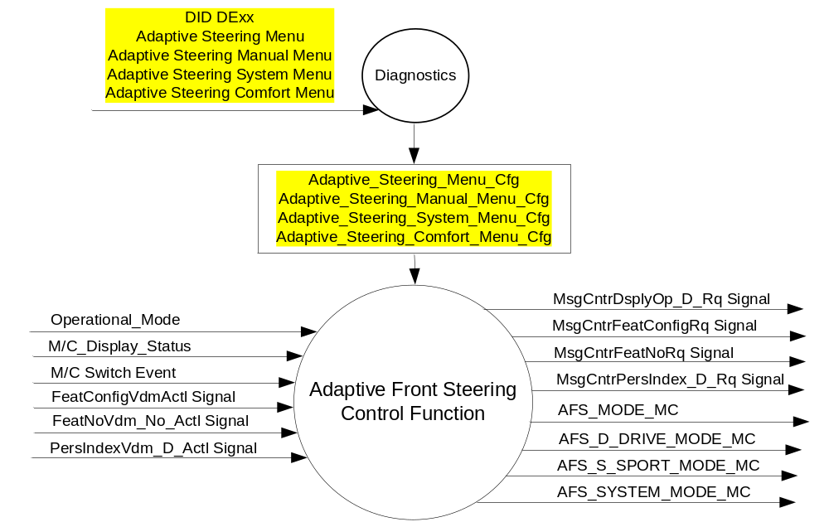

Inputs
- INTERNAL:
- Operational_Mode
- M/C Switch Event
- M/C_Display_Status
- Adaptive_Steering_Menu_Cfg
- Adaptive_Steering_Manual_Menu_Cfg
- Adaptive_Steering_System_Menu_Cfg

- MUX signals on the CAN Bus from SASM (Note: The VDM also sources this signal when present)

- FeatConfigVdmActl Signal
Signal Name | Size (bits) | Detail | Units | Res. | Offset | State Encoded | Min | Max
FeatConfigVdmActl | 16 | - | Undefined | 1 | 0 |  | 0  (0x0) | 65535  (0xFFFF)

- FeatNoVdm_No_Actl Signal
Signal Name | Size (bits) | Detail | Units | Res. | Offset | State Encoded | Min | Max
FeatNoVdm_No_Actl | 16 | - | Number | 1 | 0 |  | 0  (0x0) | 65535  (0xFFFF)

- PersIndexVdm_D_Actl Signal
Signal Name | Size (bits) | Detail | Units | Res. | Offset | State Encoded | Min | Max
PersIndexVdm_D_Actl | 3 |  | SED | 1 | 0 |  | 0  (0x0) | 7  (0x7)
 |  | PERS_1 |  |  |  | 0 (0x0)
 |  | PERS_2 |  |  |  | 1 (0x1)
 |  | PERS_3 |  |  |  | 2 (0x2)
 |  | PERS_4 |  |  |  | 3 (0x3)
 |  | Vehicle |  |  |  | 4 (0x4)
 |  | Unused |  |  |  | 5(0x5)
 |  | Unused |  |  |  | 6 (0x6)
 |  | Unused |  |  |  | 7 (0x7)

Outputs
- AFS_D_DRIVE_MODE_MC, AFS_S_SPORT_MODE_MC, AFS_MODE_MC, AFS_SYSTEM_MODE_MC
- MUX signals on the CAN Bus

- MsgCntrDsplyOp_D_Rq Signal
Signal Name | Size (bits) | Detail | Units | Res. | Offset | State Encoded | Min | Max
MsgCntrDsplyOp_D_Rq | 3 |  | SED | 1 | 0 |  | 0  (0x0) | 1  (0x7)
 |  | NULL |  |  |  | 0 (0x0)
 |  | QUERY |  |  |  | 1 (0x1)
 |  | SET |  |  |  | 2 (0x2)
 |  | UPLOAD |  |  |  | 3 (0x3)
 |  | RESTORE |  |  |  | 4 (0x4)
 |  | COPY |  |  |  | 5(0x5)
 |  | Not used |  |  |  | 6 (0x6)
 |  | Not Used |  |  |  | 7 (0x7)
.
- MsgCntrFeatConfigRq Signal
Signal Name | Size (bits) | Detail | Units | Res. | Offset | State Encoded | Min | Max
MsgCntrFeatConfigRq | 16 |  | Undefined | 1 | 0 |  | 0  (0x0) | 65535  (0xFFFF)

- MsgCntrFeatNoRq Signal
Signal Name | Size (bits) | Detail | Units | Res. | Offset | State Encoded | Min | Max
MsgCntrFeatNoRq | 16 |  | Number | 1 | 0 |  | 0  (0x0) | 65535  (0xFFFF)

- MsgCntrPersIndex_D_Rq
Signal Name | Size (bits) | Detail | Units | Res. | Offset | State Encoded | Min | Max
MsgCntrPersIndex_D_Rq | 3 |  | SED | 1 | 0 |  | 0  (0x0) | 1  (0x7)
 |  | PERS_1 |  |  |  | 0 (0x0)
 |  | PERS_2 |  |  |  | 1 (0x1)
 |  | PERS_3 |  |  |  | 2 (0x2)
 |  | PERS_4 |  |  |  | 3 (0x3)
 |  | Vehicle |  |  |  | 4 (0x4)
 |  | Not Used |  |  |  | 5 (0x5)
 |  | Not Used |  |  |  | 6 (0x6)
 |  | Not Used |  |  |  | 7 (0x7)

Function/Performance

Operational Modes

Mode | Differentiating Vehicle Conditions
Sleep Mode | Adaptive Steering Control Function Text Messages Disabled
Limiting Mode | Adaptive Steering Control Function Text Messages Disabled
Normal Mode | Adaptive Steering Control Function Text Messages Enabled / Disabled
Crank Mode | Adaptive Steering Control Function Text Message Enabled / Disabled

Voltage Levels

Refer to the Cluster Features table located in the Operational Modes and Voltage Range Strategies Section in this SPSS.

Human-Machine Interface

Visual

Indicator Graphics / Display Format
For program specific display, refer to “<Program> Cluster Menu Structure.xls”.
Example Menu Graphics:

With Adaptive_Steering_Manual_Menu_Cfg = Enabled AND Adaptive_Steering_System_Menu_Cfg = Disabled:

Menu Level 2 | Menu level 3 |  |  |  | Menu level 4
Driver Assist |  | Adaptive Steering |  | ❍ | Sport
 |  |  |  | ● | Normal

With Adaptive_Steering_Manual_Menu_Cfg = Enabled AND Adaptive_Steering_System_Menu_Cfg = Enabled:

Menu Level 2 | Menu level 3 |  |  |  | Menu level 4
Driver Assist |  | Adaptive Steering |  | ❍ | Sport
 |  |  |  | ● | Normal
 |  |  |  | ☑ | System
(Note that when System is Off, then both “Sport” and “Normal” are greyed out)

With Adaptive_Steering_Menu_Cfg = Enabled AND Adaptive_Steering_System_Menu_Cfg = Disabled AND Adaptive_Steering_Comfort_Menu_Cfg = Disabled:

Menu level 2 |  | Menu level 3 |  | Menu level 4 |  | Menu level 5
Driver Assist |  | Adaptive Steering |  | T: Adaptive Steering
 |  |  |  | Steering in "D" |  | T: Steering in "D"
 |  |  |  |  | ❍ | Sport
 |  |  |  |  | ● | Normal
 |  |  |  | Steering in "S" |  | T: Steering in "S"
 |  |  |  |  | ● | Sport
 |  |  |  |  | ❍ | Normal

With Adaptive_Steering_Menu_Cfg = Enabled AND Adaptive_Steering_System_Menu_Cfg = Enabled AND Adaptive_Steering_Comfort_Menu_Cfg = Disabled:

Menu level 2 |  | Menu level 3 |  | Menu level 4 |  | Menu level 5
Driver Assist |  | Adaptive Steering |  | T: Adaptive Steering
 |  |  |  | Steering in "D" |  | T: Steering in "D"
 |  |  |  |  | ❍ | Sport
 |  |  |  |  | ● | Normal
 |  |  |  | Steering in "S" |  | T: Steering in "S"
 |  |  |  |  | ● | Sport
 |  |  |  |  | ❍ | Normal
 |  |  |  | ☑ System
(Note that when System is Off, then both “Steering in ‘D’” and “Steering in ‘S’” are greyed out)

With Adaptive_Steering_Menu_Cfg = Enabled AND Adaptive_Steering_System_Menu_Cfg = Disabled AND Adaptive_Steering_Comfort_Menu_Cfg = Enabled:

Menu level 2 |  | Menu level 3 |  | Menu level 4 |  | Menu level 5
Driver Assist |  | Adaptive Steering |  | T: Adaptive Steering
 |  |  |  | Steering in "D" |  | T: Steering in "D"
 |  |  |  |  | ❍ | Sport
 |  |  |  |  | ● | Normal
 |  |  |  |  | ❍ | Comfort
 |  |  |  | Steering in "S" |  | T: Steering in "S"
 |  |  |  |  | ● | Sport
 |  |  |  |  | ❍ | Normal

With Adaptive_Steering_Menu_Cfg = Enabled AND Adaptive_Steering_System_Menu_Cfg = Enabled AND Adaptive_Steering_Comfort_Menu_Cfg = Enabled:

Menu level 2 |  | Menu level 3 |  | Menu level 4 |  | Menu level 5
Driver Assist |  | Adaptive Steering |  | T: Adaptive Steering
 |  |  |  | Steering in "D" |  | T: Steering in "D"
 |  |  |  |  | ❍ | Sport
 |  |  |  |  | ● | Normal
 |  |  |  |  | ❍ | Comfort
 |  |  |  | Steering in "S" |  | T: Steering in "S"
 |  |  |  |  | ● | Sport
 |  |  |  |  | ❍ | Normal
 |  |  |  | ☑ System
(Note that when System is Off, then both “Steering in ‘D’” and “Steering in ‘S’” are greyed out)

- It is a mis-configuration if Adaptive_Steering_System_Menu_Cfg = Enabled AND both Adaptive_Steering_Menu_Cfg = Disabled and Adaptive_Steering_Manual_Menu_Cfg = Disabled. In this case, none of the menus above are shown.
- Note that Adaptive_Steering_Comfort_Menu_Cfg is only applicable when Adaptive_Steering_Menu_Cfg = Enabled. Otherwise, it is Not Applicable.

Indicator Color Coordinates

Reference section COLOR & ILLUMINATION REQUIREMENTS (GRAPHICS)

Indicator Characteristics

Refer to Message Center X Display_Y Button Interface Section, where X and Y are appropriate values in this document.

Audio

None

Switch Control Logic

Consumer access to the Adaptive Steering Control Configuration shall be as specified in the message center basic functionality display as specified in Message Center X Display_Y Button Interface Section, where X and Y are appropriate values in this document.

System Accuracy

Within a 100msec of receiving a message that results in a change of state the cluster will update the display to the proper status.

Operation: Performance and Functional

Subsystem Algorithm Flowchart / State Diagram

Figure 2 AFS Diagnostic Configuration Flowchart
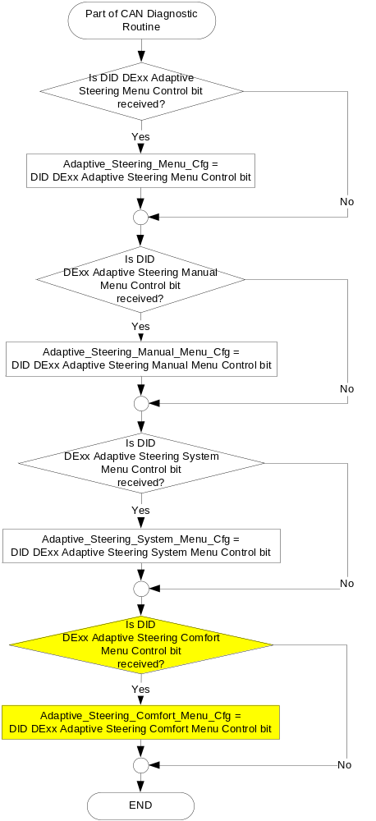

Figure 3: SASM input request Flowcharts

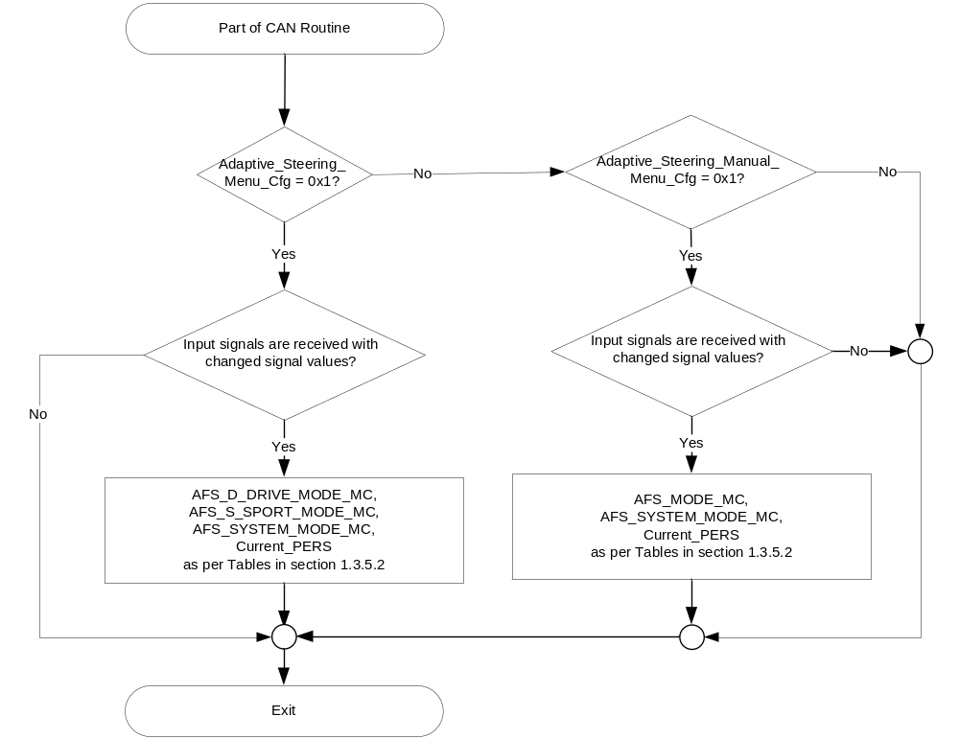

Figure 4: SASM output SET request Flowchart

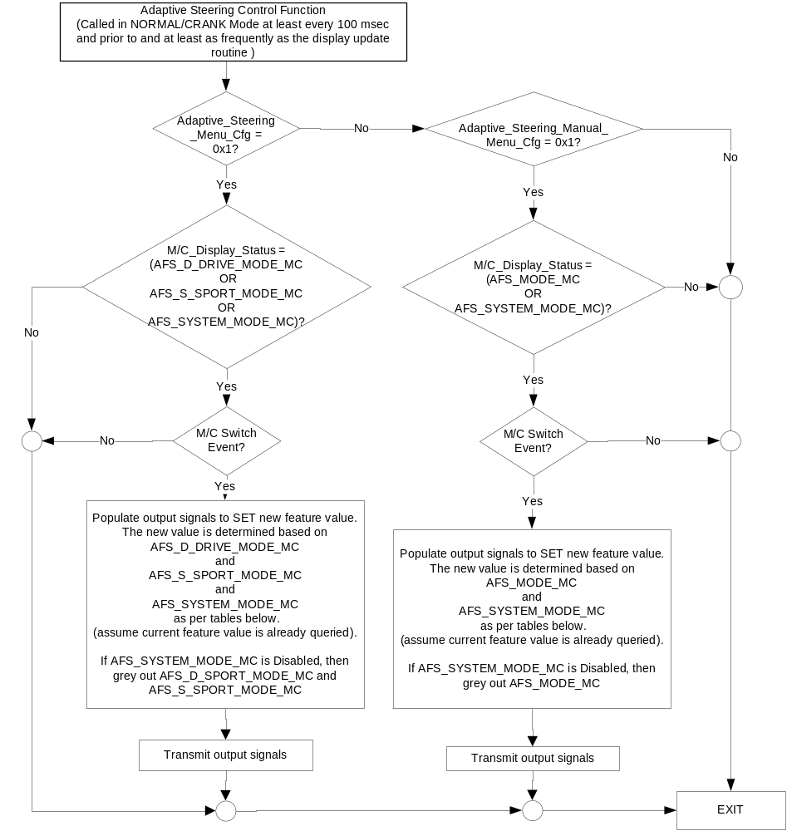

NOTE: In the Adaptive Steering Control Function Flowchart, the definition of "M/C Switch Event" is defined in Message Center X Display_Y Button Interface Section, where X and Y are appropriate values in this document.

- AFS_MODE_MC State Assignment
FeatNoVdmActl | FeatConfigVdmActl | PersIndexVdm_D_Actl | AFS_MODE_MC | Current_PERS ⁽³⁾
0x0B00 ⁽¹⁾ | Normal  (0x0002) | 0x0 – 0x4 | Normal  (0x2) | 0x0 – 0x4
0x0B00 ⁽¹⁾ | Sport  (0x0003) | 0x0 – 0x4 | Sport  (0x3) | 0x0 – 0x4
0x0B00 ⁽¹⁾ | Other ⁽²⁾ |  | Error  (0x4) | Last Known
Missing per Section 1.4.1 ⁽²⁾ |  |  | Error  (0x4) | Last Known

⁽¹⁾ CCD Drive Mode Enable Feature Number. Reference is Feat Num table in “Vehicle Personalization FS”
⁽²⁾ Message data is Faulted
⁽³⁾ Equal to the received “PersIndex<--->” signal value . When faulted Keep last known value.

- Message Center Display and MC AFS Request Messages

based upon AFS_MODE_MC
AFS_MODE_MC | Display Menu | 5-Button Switch Selection Event | MsgCntrDsplyOp_D_Rq  Signal | MsgCntrFeatNoRq  Signal | MsgCntrFeatConfigRq  Signal | MsgCntrPersIndex_D_Rq  Signal
Sport  (0x3) | 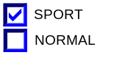 | Up/Down + OK (Select NORMAL) | SET (0x2) | 0x0B00 | 0x0002 (if NORMAL is selected) | Current_PERS
Normal  (0x2) | 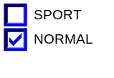 | Up/Down + OK (Select SPORT) | SET (0x2) | 0x0B00 | 0x0003 (if SPORT is selected) | Current_PERS
Error  (0x4) | 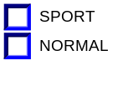 | Up/Down + OK (Select SPORT or NORMAL) | SET (0x2) | 0x0B00 | 0x0003 (if SPORT is selected)  0x0002 (if NORMAL is selected) | Current_PERS

- AFS_D_DRIVE_MODE_MC State Assignment
FeatNoVdmActl | FeatConfigVdmActl | PersIndexVdm_D_Actl | AFS_D_DRIVE_MODE_MC | Current_PERS ⁽³⁾
0x0B00 ⁽¹⁾ | Comfort⁽⁴⁾  (0x0001) | 0x0 – 0x4 | Comfort  (0x1) | 0x0 – 0x4
0x0B00 ⁽¹⁾ | Normal  (0x0002) | 0x0 – 0x4 | Normal  (0x2) | 0x0 – 0x4
0x0B00 ⁽¹⁾ | Sport  (0x0003) | 0x0 – 0x4 | Sport  (0x3) | 0x0 – 0x4
0x0B00 ⁽¹⁾ | Other ⁽²⁾ |  | Error  (0x4) | Last Known
Missing per Section 1.4.1 ⁽²⁾ |  |  | Error  (0x4) | Last Known

⁽¹⁾ CCD Drive Mode Enable Feature Number. Reference is Feat Num table in “Vehicle Personalization FS”
⁽²⁾ Message data is Faulted
⁽³⁾ Equal to the received “PersIndex<--->” signal value . When faulted Keep last known value.
⁽⁴⁾ Supprorted if Adaptive_Steering_Comfort_Menu_Cfg = Enabled. If Adaptive_Steering_Comfort_Menu_Cfg = Disabled and “Comfort” is received, then AFS_D_DRIVE_MODE_MC is set to Error (0x4).

- Message Center Display and MC AFS Request Messages

based upon AFS_D_DRIVE_MODE_MC
Adaptive_Steering_Comfort_Menu_Cfg | AFS_D_  DRIVE_  MODE_MC | Display Menu | 5-Button Switch Selection Event | MsgCntrDsplyOp_D_Rq  Signal | MsgCntrFeatNoRq  Signal | MsgCntrFeatConfigRq  Signal | MsgCntrPersIndex_D_Rq  Signal
Disabled | Sport  (0x3) |  | Up/Down + OK (Select NORMAL) | SET (0x2) | 0x0B00 | 0x0002 (if NORMAL is selected) | Current_PERS
Disabled | Normal  (0x2) |  | Up/Down + OK (Select SPORT) | SET (0x2) | 0x0B00 | 0x0003 (if SPORT is selected) | Current_PERS
Disabled | Error  (0x4) |  | Up/Down + OK (Select SPORT or NORMAL) | SET (0x2) | 0x0B00 | 0x0003 (if SPORT is selected)  0x0002 (if NORMAL is selected) | Current_PERS
Enabled | Sport  (0x3) | 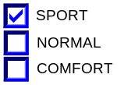 | Up/Down + OK (Select NORMAL or COMFORT) | SET (0x2) | 0x0B00 | 0x0002 (if NORMAL is selected)  0x0001 (if COMFORT Is selected) | Current_PERS
Enabled | Normal  (0x2) | 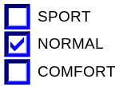 | Up/Down + OK (Select SPORT or COMFORT) | SET (0x2) | 0x0B00 | 0x0003 (if SPORT is selected)  0x0001 (if COMFORT Is selected) | Current_PERS
Enabled | Comfort  (0x1) | 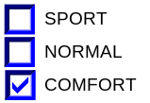 | Up/Down + OK (Select SPORT or NORMAL ) | SET (0x2) | 0x0B00 | 0x0003 (if SPORT is selected)  0x0002 (if NORMAL is selected) | Current_PERS
Enabled | Error  (0x4) | 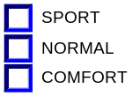 | Up/Down + OK (Select SPORT, NORMAL or COMFORT) | SET (0x2) | 0x0B00 | 0x0003 (if SPORT is selected)  0x0002 (if NORMAL is selected)  0x0001 (if COMFORT is selected) | Current_PERS

- AFS_S_SPORT_MODE_MC State Assignment
FeatNoVdmActl | FeatConfigVdmActl | PersIndexVdm_D_Actl | AFS_S_SPORT_MODE_MC | Current_PERS ⁽³⁾
0x0B01 ⁽¹⁾ | Normal  (0x0002) | 0x0 – 0x4 | Normal  (0x2) | 0x0 – 0x4
0x0B01 ⁽¹⁾ | Sport  (0x0003) | 0x0 – 0x4 | Sport  (0x3) | 0x0 – 0x4
0x0B01 ⁽¹⁾ | Other ⁽²⁾ |  | Error  (0x4) | Last Known
Missing per Section 1.4.1 ⁽²⁾ |  |  | Error  (0x4) | Last Known

⁽¹⁾ CCD Sport Mode Enable Feature Number. Reference is Feat Num table in “Vehicle Personalization FS”
⁽²⁾ Message data is Faulted
⁽³⁾ Equal to the received “PersIndex<--->” signal value . When faulted Keep last known value.

- Message Center Display and MC CCD Request Messages

based upon AFS_S_SPORT_MODE_MC
AFS_S_  SPORT_  MODE_MC | Display Menu | 5-Button Switch Selection Event | MsgCntrDsplyOp_D_Rq  Signal | MsgCntrFeatNoRq  Signal | MsgCntrFeatConfigRq  Signal | MsgCntrPersIndex_D_Rq  Signal
Sport  (0x3) |  | Up/Down + OK (Select NORMAL) | SET (0x2) | 0x0B01 | 0x0002 (if NORMAL is selected) | Current_PERS
Normal  (0x2) |  | Up/Down + OK (Select SPORT) | SET (0x2) | 0x0B01 | 0x0003 (if SPORT is selected) | Current_PERS
Error  (0x4) |  | Up/Down + OK (Select SPORT or NORMAL) | SET (0x2) | 0x0B01 | 0x0003 (if SPORT is selected)  0x0002 (if NORMAL is selected) | Current_PERS

- AFS_SYSTEM_MODE_MC State Assignment
FeatNoVdmActl | FeatConfigVdmActl | PersIndexVdm_D_Actl | AFS_SYSTEM_  MODE_MC | Current_PERS ⁽³⁾
0x0B02 ⁽¹⁾ | Disabled  (0x0000) | 0x0 – 0x4 | Disabled  (0x0) | 0x0 – 0x4
0x0B02 ⁽¹⁾ | Enable  (0x0001) | 0x0 – 0x4 | Enable  (0x1) | 0x0 – 0x4
0x0B02 ⁽¹⁾ | Other ⁽²⁾ |  | Error  (0x4) | Last Known
Missing per Section 1.4.1 ⁽²⁾ |  |  | Error  (0x4) | Last Known

⁽¹⁾ Adaptive Steering System Display Feature Number. Reference is Feat Num table in “Vehicle Personalization FS”
⁽²⁾ Message data is Faulted
⁽³⁾ Equal to the received “PersIndex<--->” signal value . When faulted Keep last known value.

- Message Center Display and MC CCD Request Messages

based upon AFS_SYSTEM_MODE_MC
AFS_SYSTEM_MODE_MC | Display Menu | 5-Button Switch Selection Event | MsgCntrDsplyOp_D_Rq  Signal | MsgCntrFeatNoRq  Signal | MsgCntrFeatConfigRq  Signal | MsgCntrPersIndex_D_Rq  Signal
Disabled  (0x0) |  | Up/Down + OK (Select Enable) | SET (0x2) | 0x0B02 | 0x0001 (if ENABLE is selected) | Current_PERS
Enable  (0x1) |  | Up/Down + OK (Select Disable) | SET (0x2) | 0x0B02 | 0x0000 (if DISABLED is selected) | Current_PERS
Error  (0x4) | 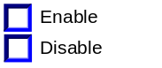 | Up/Down + OK (Select Enable or Disable) | SET (0x2) | 0x0B02 | 0x0001 (if ENABLE is selected)  0x0000 (if DISABLED is selected) | Current_PERS

Operation Description (supports algorithm flowchart /state diagram)
- For definition of how the Message Center arbitrates and displays Active warnings, see the Warning / Alert Display Logic Diagram, located in the Message Center – X Display with W Button Interface section of this SPSS (where X and W are appropriate values in this document).
- Personalization Feature Number definitions:
Feature Name | Feature Num | Cfg Num | Cfg Value | MyKey Limited | Personalization Type
CCD Gear in Drive | 0x0B00 | 0x00 | No Mode Selected | Full | Movable
CCD Gear in Drive | 0x0B00 | 0x01 | Comfort | Full | Movable
CCD Gear in Drive | 0x0B00 | 0x02 | Normal | Full | Movable
CCD Gear in Drive | 0x0B00 | 0x03 | Sport | Full | Movable
CCD Gear in Sport | 0x0B01 | 0x00 | No Mode Selected | Full | Movable
CCD Gear in Sport | 0x0B01 | 0x01 | Comfort | Full | Movable
CCD Gear in Sport | 0x0B01 | 0x02 | Normal | Full | Movable
CCD Gear in Sport | 0x0B01 | 0x03 | Sport | Full | Movable
Adaptive Steering System Display | 0x0B02 | 0x00 | Disabled | Full | Movable
Adaptive Steering System Display | 0x0B02 | 0x01 | Enable | Full | Movable

Note: 0x0B00 Feature Number is used for both “Adaptive Steering – Steering in ‘D’ ” menu and “Adaptive Steering” menu.

Function Safety Classification (EMC)

Class B

Memory Storage
Parameter Name | Description | Value at  Battery Connect | Value at  Module Wake-up
AFS_D_DRIVE_MODE_MC | Output displayed in the M/C for Adaptive Steering setting when transmission is in “D” (drive). | Disabled (0x0) | Do Not Init
AFS_S_SPORT_MODE_MC | Output displayed in the M/C for Adaptive Steering setting when transmission is in “S” (sport). | Disabled (0x0) | Do Not Init
AFS_MODE_MC | Output displayed in the M/C for Adaptive Steering setting when manual transmission. | Disabled (0x0) | Do Not Init
AFS_SYSTEM_MODE_MC | Output displayed in the M/C for Adaptive Steering System setting. This is tied to either the Adaptive Steering Menu or the Adaptive Steering Manual Menu. | Disabled (0x0) | Do Not Init
MsgCntrDsplyOp_D_Rq Signal | Output Signal to indicate Request Type. | NULL (0x0) | Do Not Init
MsgCntrFeatNoRq Signal | Output Signal to indicate Feature Number. | (0x0000) | Do Not Init
MsgCntrFeatConfigRq Signal | Output Signal to Specify the desired feature Value. | (0x0000) | Do Not Init
MsgCntrPersIndex_D_Rq Signal | Output Signal to indicate which personality profile is being accessed. | Vehicle (0x4) | Do Not Init
FeatNoVdm_No_Actl Signal | Input signal sent from VDM or SASM to indicate Feature Number. | (0x0000) | Do Not Init
FeatConfigVdmActl Signal | Input signal sent from VDM or SASM to indicate current value of the feature setting for the feature that is being set or queried. | (0x0000) | Do Not Init
PersIndexVdm_D_Actl Signal | Input signal sent from VDM or SASM to indicate which personality profile is being reported. | Vehicle (0x4) | Do Not Init
Adaptive_Steering_Menu_Cfg | Configures cluster to allow display of Adaptive Steering Menu for an Automatic vehicle. Set to Disabled at Cluster Supplier Manufacturing Plant. | Use Stored Value | Use Stored Value
Adaptive_Steering_Manual_Menu_Cfg | Configures cluster to allow display of Adaptive Steering Menu for a manual transmission vehicle. Set to Disabled at Cluster Supplier Manufacturing Plant. | Use Stored Value | Use Stored Value
Adaptive_Steering_Comfort_Menu_Cfg | This feature adds the additional choice of “Comfort” to Adaptive Steering, Stering in “D” menu. Note that Adaptive_Steering_Menu_Cfg must be enabled along with this item.  This config is necessary to differentiate between a Ford with AFS and a Lincoln with AFS. See 1.5.3.1 for options.  Set to Disabled at Cluster Supplier Manufacturing Plant. | Use Stored Value | Use Stored Value
Adaptive_Steering_System_Cfg | This feature adds the additional choice of “System On/Off” to whichever of the 2 menus above are enabled (Adaptive Steering Menu or Adaptive Steering Manual Menu). Note that 1 of the 2 menus above must be enabled along with this item.  This config is necessary to prevent a coordinated change between cluster and AFS. (i.e. pre-MY18 AFS modules may not support “System On/Off” which is Feature Number 0x0B02). The correct setting of this bit is dependent on the AFS module software level, and needs to be approved by Jeremy Rawlings or other AFS (SASM) D&R.  Set to Disabled at Cluster Supplier Manufacturing Plant. | Use Stored Value | Use Stored Value
M/C_Display_Status | State Indicator to identify which text is currently being displayed on Message Center display. See * | See * below | See * below
M/C Switch Event | Event that is indicated as per the switch interface for the Message Center. See * | See * below | See * below
Operational_Mode | 4 state indicator for cluster operational mode | Limited | Limited, Normal or Crank
* Refer to Message Center X Display_Y Button Interface Section, where X and Y are appropriate values in this document.

Reconfigurable Telltale

Not Applicable

Prove Out

Not applicable

Message Center Msg

None.

Error Handling

Missing Message Strategy

The signals will be declared missing as per the Diagnostics section of this SPSS.

DTCs states and history will be determined as per the Diagnostics section of this SPSS.

If Adaptive_Steering_Menu_Cfg = Disabled, the cluster shall never log a missing message for this feature.

Diagnostics

Self Test

None

Engineering Test Mode

Reference section “Dealer / Engineering Test Mode (ETM)”

Part II Performance

Supported Diagnostic Trouble Codes (DTCs)

DTCs shall be logged as per the diagnostics section of this SPSS.*

DTC | Description | Comments
C12600 | Lost Communication With Steering Angle Sensor Module | 5sec and Adaptive_Steering_Menu_Cfg Enabled.
C42882 | Invalid Data Received From Steering Angle Sensor Module | 5sec and Adaptive_Steering_Menu_Cfg Enabled.
* If the missing signal has a related update bit, _UB, signal, then the “Invalid Data” DTC is to be logged. Otherwise, the “Lost Communication” DTC is logged.

DID DExx:
Block  Num | Block Description | Size (bits) | Type | Byte(s) | Bits | State: Description | "0" | "1" | Default | Comments/Information
PACKETED BLOCKS
$xx | Option Content (B&A) | * | 1 | * | * | Adaptive Steering Menu | Disabled | Enabled | Disabled | When enab led, the Adaptive Steering – Steering in “D”/Steering in “S” menu is displayed in the cluster Driver Assist menu. Feature requires SASM module in vehicle.  Enable for vehicles that have AFS and an automatic transmission but do NOT have a VDM.  Disabled means the menu is not present in the vehicle
 |  | * | 1 | * | * | Adaptive Steering Manual Menu | Disabled | Enabled | Disabled | When enab led, the Adaptive Steering menu is displayed in the cluster Driver Assist menu. Feature requires SASM module in vehicle.  Enable for vehicles that have AFS and a manual transmission but do NOT have a VDM.  Disabled means the menu is not present in the vehicle
 |  | * | 1 | * | * | Adaptive Steering Comfort Menu | Disabled | Enabled | Disabled | This feature adds the additional choice of “Comfort” to Adaptive Steering, Stering in “D” menu. Note that Adaptive_Steering_Menu_Cfg must be enabled along with this item.  This config is necessary to differentiate between a Ford with AFS and a Lincoln with AFS. See 1.5.3.1 for options.
 |  | * | 1 | * | * | Adaptive Steering System Menu | Disabled | Enabled | Disabled | This feature adds the additional choice of “System On/Off” to whichever of the 2 menus above are enabled (Adaptive Steering Menu or Adaptive Steering Manual Menu). Note that 1 of the 2 menus above must be enabled along with this item.  This config is necessary to prevent a coordinated change between cluster and AFS. (i.e. pre-MY18 AFS modules may not support “System On/Off” which is Feature Number 0x0B02). The correct setting of this bit is dependent on the AFS module software level, and needs to be approved by Jeremy Rawlings or other AFS (SASM) D&R.
 | *Byte and bit location to be identified in Part II Specification for this cluster

Part II Reference – NOTE: THIS IS NOT A REQUIREMENT SECTION. IT IS A REFERENCE GUIDE TO THE IC D&R and NETCOM TO DEVELOP THE VSCS.

- There are 3 STSS’ involved with CCD (VDM) and AFS (SASM). These are:
CCD Control Function w Adaptive Drive - CGEA1.3_vx.x.doc (The table below is duplicated in this STSS as well)
Adaptive Steering Control Function - CGEA1.3_vx.x.doc
Active Front Steering RTT and Messages - CGEA 1.3_vx.x.doc

- There are 7 different configuration parameters involved for 8 vehicle variants. Below is a summary that will assist in setting up the VSCS.

Adaptive Steering/Lincoln Adaptive Drive Configuration Table:
Vehicle Description | AFS_Cfg  (Turns on AFS RTT and Warnings W2125-W2128) | Adaptive_Steering_Manual_  Menu_Cfg  (Turns on “Adaptive Steering – Sport/Normal” menu) | Adaptive_Steering_Menu_Cfg  (Turns on “Adaptive Steering in Drive/Sport” menus) | Adaptive_Steering_Comfort_Menu_Cfg  (Turns on “Comfort” as a choice in the “Adaptive Steering in Drive” menu) |  | CCD_Cfg:  Allows CcdMsgTxt_D_RqDsply signal, which triggers:  W1026 Ford  W1027 Lincoln | Drive_Control_Menu_Cfg  (Turns on “Drive Control – Sport/Normal/Comfort” menu) | Adaptive_Drive_Menu_Cfg  (Turns on Lincoln “Adaptive Drive Handling in D/S, Performance in S” menus)
Lincoln with CCD only | Disabled | Disabled | Disabled | X  (Set to Disabled) |  | Enabled  (will show W1027) | Disabled | Enabled
Lincoln with CCD and AFS | Enabled | Disabled | Disabled | X  (Set to Disabled) |  | Enabled  (will show W1027) | Disabled | Enabled
Lincoln with AFS | Enabled | Disabled | Enabled | Enabled  (Show “Comfort”) |  | Disabled | Disabled | Disabled
Ford with AFS and Auto Trans (no CCD) | Enabled | Disabled | Enabled | Disabled |  | Disabled | Disabled | Disabled
Ford with AFS and Manual Trans (no CCD) | Enabled | Enabled | Disabled | X  (Set to Disabled) |  | Disabled | Disabled | Disabled
Ford with CCD and AFS | Enabled | Disabled | Disabled | X  (Set to Disabled) |  | Enabled  (will show W1027) | Enabled | Disabled
Ford with CCD only | Disabled | Disabled | Disabled | X  (Set to Disabled) |  | Enabled  (will show W1027) | Enabled | Disabled
Ford No AFS, No CCD | Disabled | Disabled | Disabled | X  (Set to Disabled) |  | Disabled | Disabled | Disabled

Reference Specification

None.

Revision History
SPSS Module Revision History
Revision Level | Name | Change Description | Date
1.0 | S. Watkins | Initial release. Input from feature owners Miguel Bahena and Andrew Brown (Technical) and Johanna Slanga (HMI). Based off CCD Control Function w Adaptive Drive - CGEA1.3_v4.0.doc. | 10/8/2013
2.0 | S. Watkins | Major re-write to add in another set of HMI menus.  AFS personalization on CD539E/X and CD390 (Jeremy Rawlings) – Approved for STSS update in DI Change Control 10/9/2014.  Updates are directed first for CD539E/X and CD390. Changes marked in yellow throughout, but treat as new STSS. | 11/13/2014
3.0 | S. Watkins | Medium level modifications to bring in the customer ability to turn off AFS. This adds the choice of “Adaptive Steering -> System -> On/Off” to both the Automatic and the manual menu.  Approved in DI Change Control on 5/28/2015. Feature owner Jeremy Rawlings.  This requires a new Feature Number 0x0B02 (Adaptive Steering System Display). The use of the new Feature Number requires the definition of a new DExx config so that updates to the cluster and the AFS do not have to be coordinated. | 6/11/2015
4.0 | S. Watkins | Request to add “Comfort” as a menu selection on Lincoln without CCD and AFS. Feature owner Jeremy Rawlings, also worked with Andy Reid, David Russell. At this time, Lincoln will have “Comfort” but not Ford, so a new configuration is added (Adaptive_Steering_Comfort_Menu_Cfg). Since the AFS module already supports “Comfort”, this config can be enabled immediately on Lincolns with AFS.  - Section 1.2.1 – Added new config, Adaptive_Steering_Comfort_Menu_Cfg  - Section 1.3.3.2 – Added 2 new HMI displays showing “Comfort” when Adaptive_Steering_Comfort_Menu_Cfg = Enabled. Also added 2nd bullet point below menus.  - Section 1.3.5.1 – Updated Figure 2 with new config, Adaptive_Steering_Comfort_Menu_Cfg.  - Section 1.3.5.1 – Updated Table 1.9 and Table 1.10 for “Comfort” and new config Adaptive_Steering_Comfort_Menu_Cfg.  - Section 1.3.5.4 – Added Adaptive_Steering_Comfort_Menu_Cfg  - Section 1.5.3 - Added Adaptive_Steering_Comfort_Menu_Cfg  - Section 1.5.3.1 - Added Adaptive_Steering_Comfort_Menu_Cfg | 8/3/2015

